**Experiment No.1**

**Program 1:**

//Code to find factorial of a number

import java.util.*;

public class Exp1Java{

public static void main(String[] args){

int fact=1,n;

Scanner factorial=new Scanner (System.in);

System.out.println("Enter any Number:");

n=factorial.nextInt();

for(int i=1;i<=n;i++)

{

fact=fact*i;

}

System.out.println("factorial of"+n+"is"+fact);

}

}

**OUTPUT:**

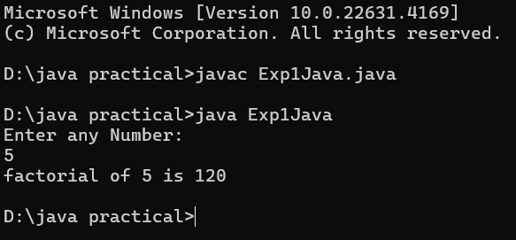

**Program 2:**

public class exp1_2{

public static void main(String[] args){

int i,j, factor;

for(i=1;i<=50;i++)

{

factor=0;

for(j=1;j<=i;j++)

{

if(i%j==0)

factor++;

}

if(factor==2)

System.out.println(i);

}

}

}

**OUTPUT** **:**

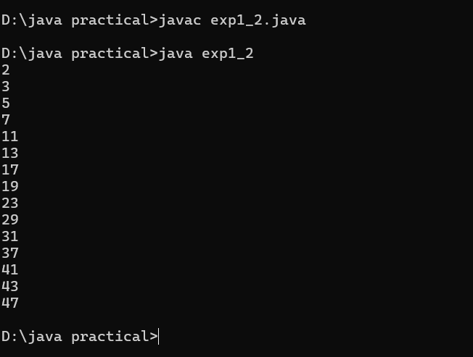

**Program 3:**

//code to find sum and average of n numbers

import java.util.Scanner;

public class Exp1sum{

public static void main(String[] args){

Scanner scanner=new Scanner(System.in);

System.out.print("Enter the number of values:");

int n=scanner.nextInt();

int sum=0;

for(int i=1;i<=n;i++)

{

System.out.print("Enter Value "+" :");

int value=scanner.nextInt();

sum+=value;

}

double average=(double)sum/n;

System.out.println("Sum:"+sum);

System.out.println("Average:"+average);

scanner.close();

}

}**OUTPUT:** 